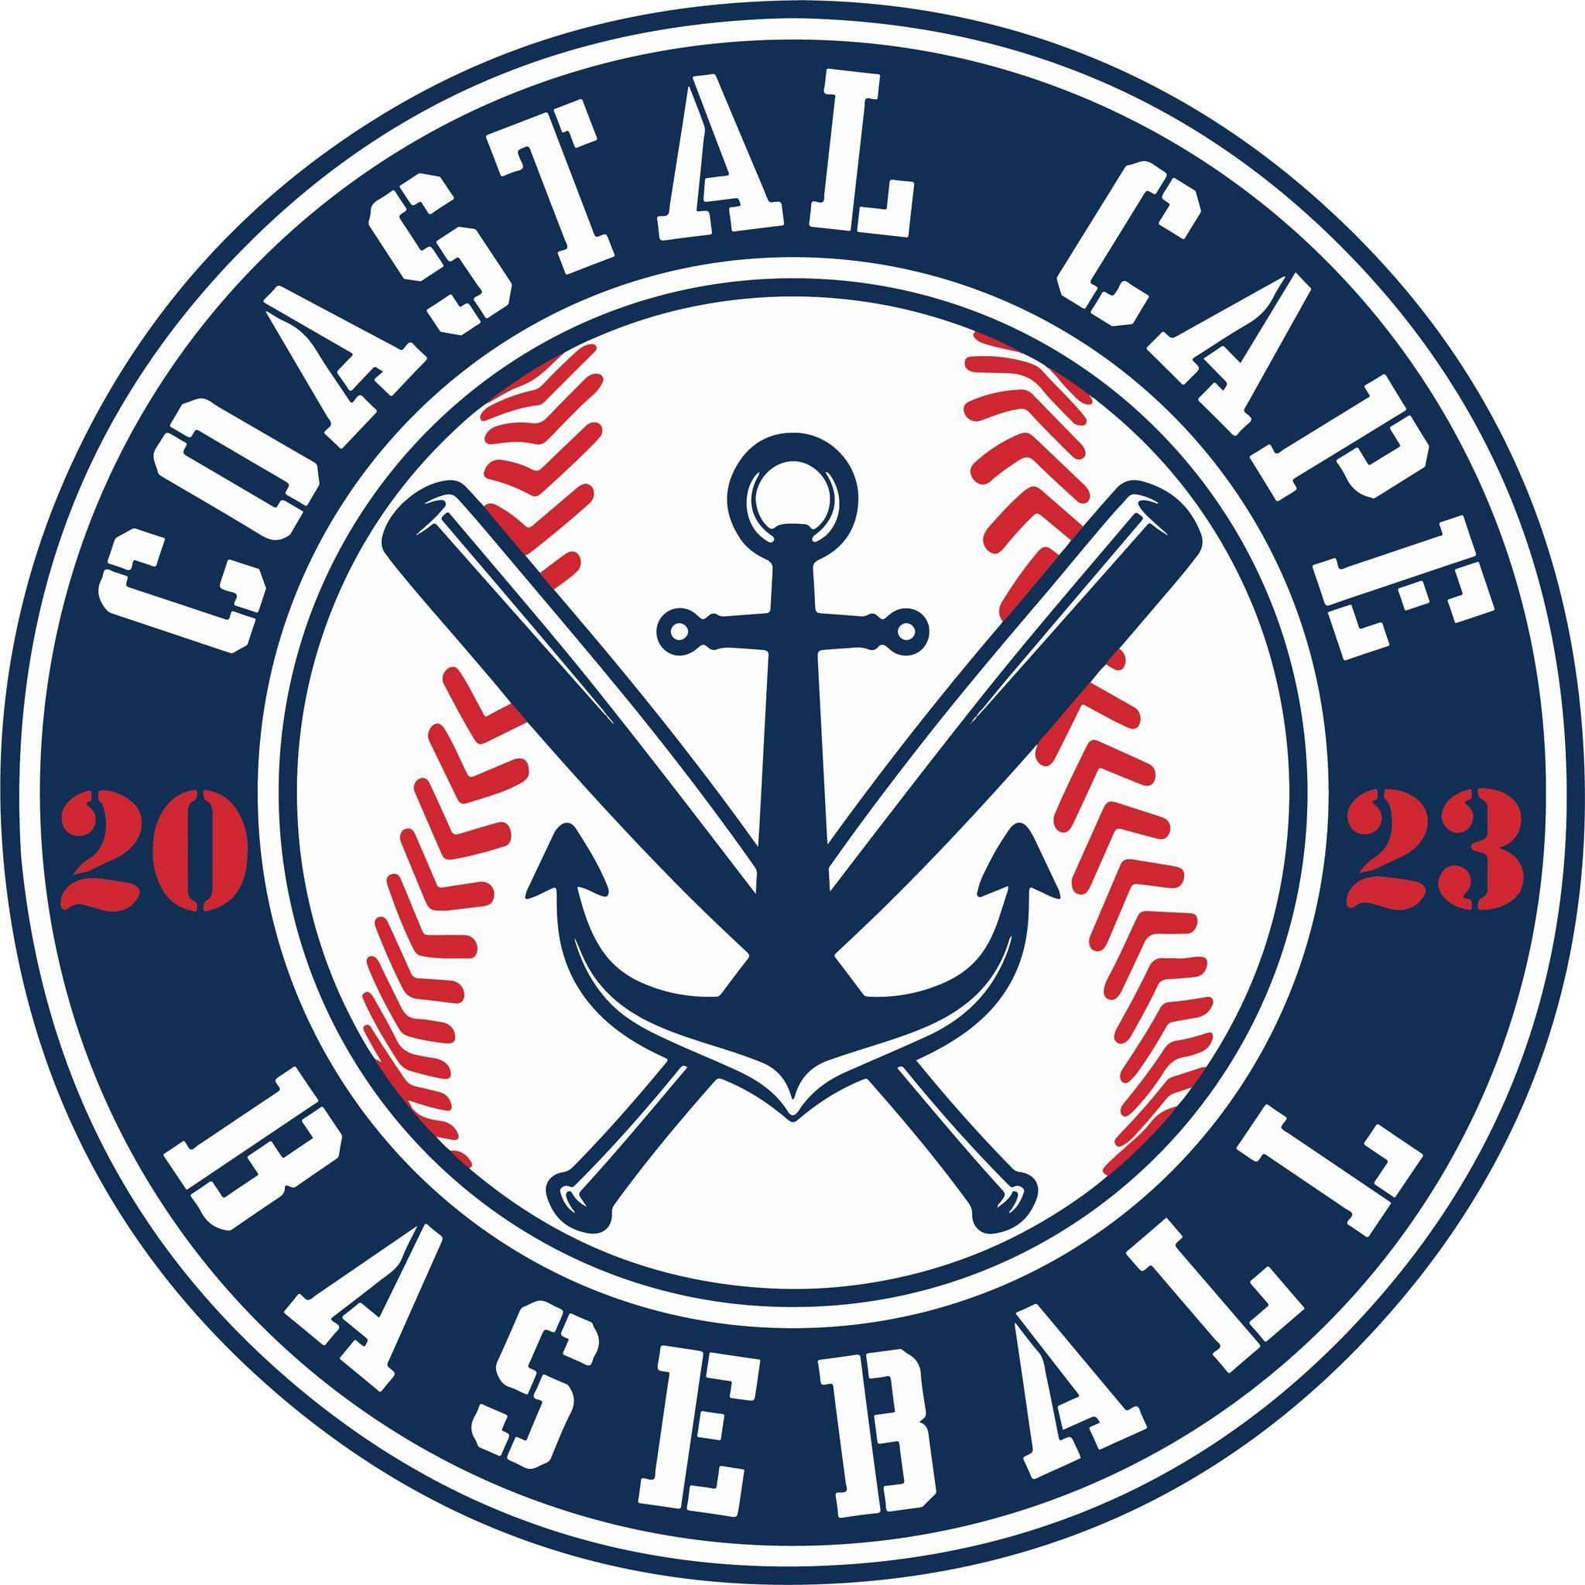

Board Meeting Notes
Date: ________3/9/26______________

Important Dates and Meeting Agenda
(Prior to the Meeting)
Upcoming Important Dates: Opening Day – April 11th , Fenway Day – June 30th

Next Meeting: Monday, April 6th
Agenda:
- Meeting Minutes
- Financials
- Draft
- Coaches
- Umpires
- Opening Day
- Sponsors
- Fundraising
- Fenway Day
- Chains & Helmet pins

- Notetaker - Abby Nye
- Timekeeper
- Discussion Monitor

Topic: Secretary/ Meeting Minutes | Presenter:  Time: 6:05
Notes:  - Minutes have been added to website | Actions Items:  - February Minutes approved

Topic: Financials | Presenter: Ken/ All  Time: 6:05-6:15
Notes:  - Taxes completed  - Uniforms have been ordered  - We have enough baseballs for next year  - Field supplies ordered | Actions Items:

Topic: Draft | Presenter: All  Time: 6:15-6:42
Notes:  - Majors draft complete – 4 teams of 12 players  - Minors draft complete – 4 teams  - Rookies draft open – waiting on 1 coach  - #HEINZSIGHT | Actions Items:  - Finish rostering rookies and post to social

Topic: Coaches | Presenter: All  Time: 6:42-6:49
Notes:  - Majors – coaches confirmed  - Minors – coaches confirmed  - Rookies – waiting on 1 | Actions Items:  - working through background checks

Topic: Umpires | Presenter: All  Time: 6:49-6:53
Notes:  - Patched $110/game  - Playoffs 2 patched  - Minors $90/ game for 2 jr. umpires | Actions Items:  - Ask jr umpires to set up venmo

Topic: Opening Day | Presenter: All  Time: 6:53-7:27
Notes:  - Julie Bray singing national anthem  - 9am opening ceremonies, Saturday April 11  - Ken to thank all the sponsors  - Busy Bees inflatables  - Face painting  - Raffle  - 11:00 am and 1:30pm majors games | Actions Items:  - Allen will contact seniors at Monomoy and Nauset for first pitch  - Ken to find DJ, motion approve $500 budget,  - Guest speaker – Kelly to ask Uncle John Schiffner and Ken to talk to Lou  - Abby to calling Brewster VFW for color guard, possible donation to VFW  - Motion approve $850 for 2 bounce houses,  - Ken secured ice cream truck

Topic: Sponsors | Presenter: Bianca/ All  Time: 7:27- 7:37
Notes:  - Leighton, Callahan, Coastal Chatham and Pilgrim Church are unpaid | Actions Items:  - Bianca ordering banners for Lower Cape Carpentry, Coastal Chatham  - Inviting to opening day

Topic: Fundraising | Presenter: Bianca  Time: 7:37- 7:56
Notes:  - Packets assembled for coaches with raffle info  - Opening day raffles  - Player prizes – top 3 players at each division - $500 Butlers, Dicks Sporting Goods and Membership to Baseball Club  - Team prize – Top selling per division - $200 per team at sponsor location | Actions Items:  - Raffle tickets and money collected by May 25  - Motion approve player and team prizes

Topic: Fenway Day | Presenter: Kelly/ All  Time: 7:56-8:27
Notes:  - Sell 150 tickets to unlock players on field  - Add $5.00 to ticket price for fundraising  - Bus TBD | Actions Items:  - Motion to allow board kids on field plus remaining spot from players buying a ticket to Fenway, VOTE= 6 no, 4 yes  - Table further discussion on the vote and how field spots will be used

Topic: Helmet stickers/ Chains | Presenter: Kelly  Time: 8:27-8:29
Notes: | Actions Items:  - Approved to buy 12 chains and helmet stickers

Topic: | Presenter:  Time:
Notes: | Actions Items:

