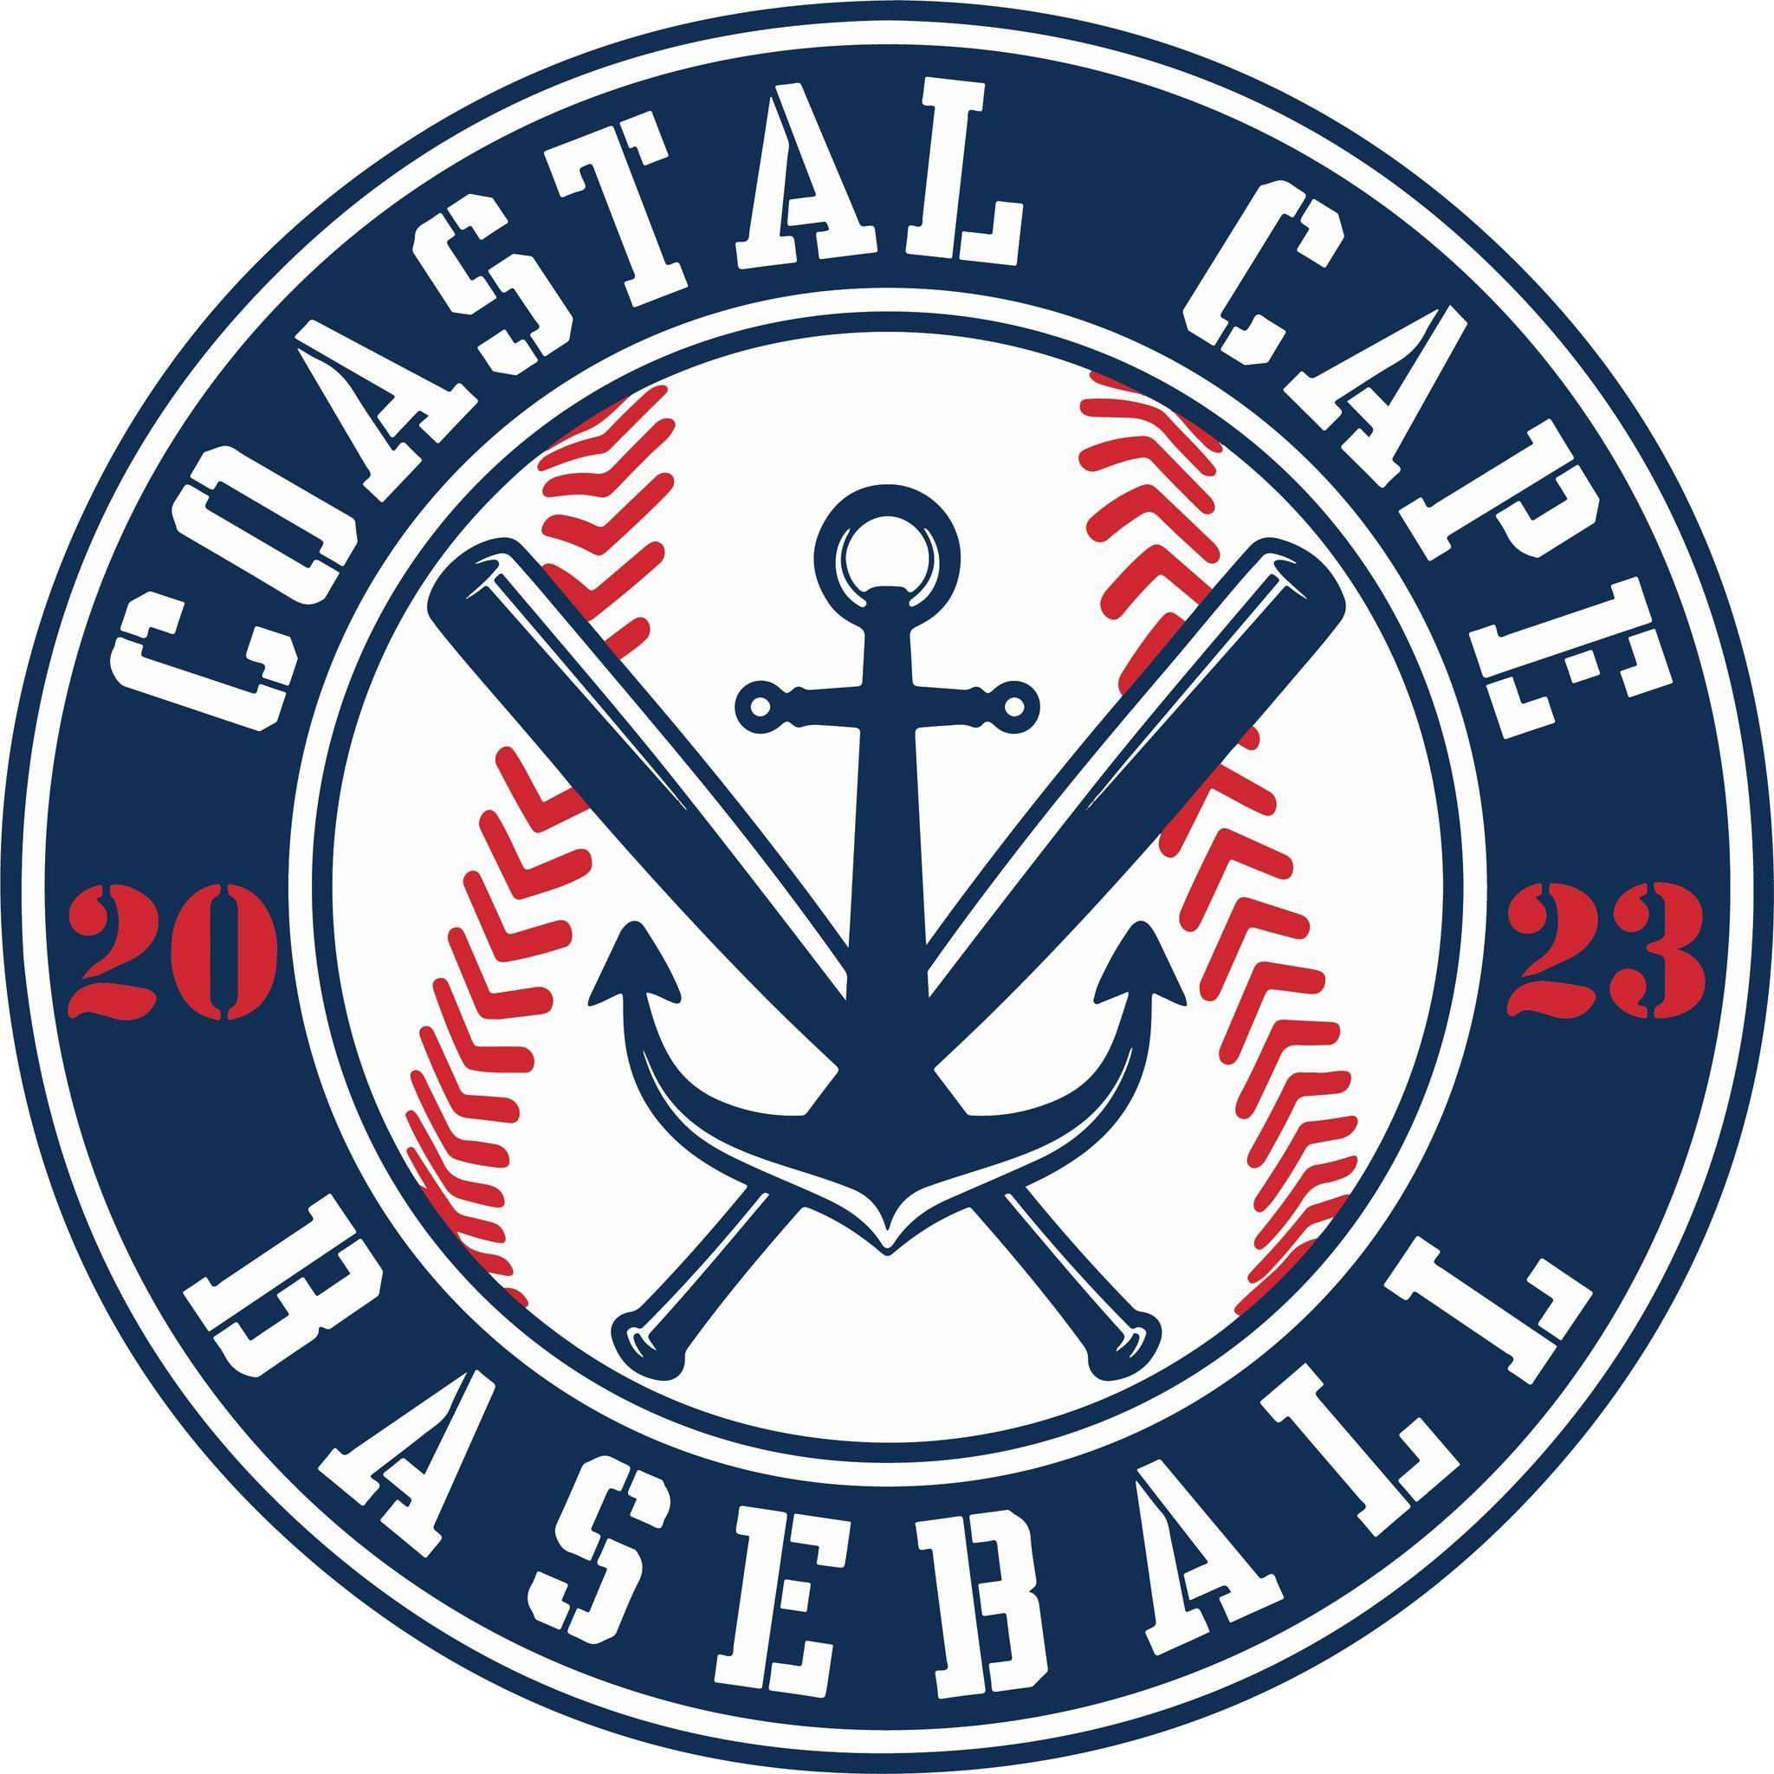

Board Meeting Notes
Date: ________4/9/26______________

Important Dates and Meeting Agenda
(Prior to the Meeting)
Upcoming Important Dates: Opening Day 4/11/26, Coastal Cape Fenway Day 6/30/26,

Next Meeting: May
Agenda:
- Minutes
- Treasury Update
- Opening Day
- Sponsors
- Raffle
- Background check
- Fenway
- Centeio
- Notetaker - Abby Nye
- Timekeeper
- Discussion Monitor

Topic: Meeting Minutes | Presenter: Abby  Time: 6:05-6:06
Notes: | Actions Items:  - Motion to approve 3/9/26 meeting minutes, approved

Topic: Treasury Update | Presenter: Ken  Time: 6:06-6:10
Notes:  - Debit card was replaced due to fraud  - Red Sox will send check for fundraiser ticket sales | Actions Items:

Topic: Opening Day | Presenter: All  Time: 6:10-6:23
Notes:  - See agenda doc | Actions Items:

Topic: Sponsors | Presenter: Bianca  Time: 7:23-7:30
Notes:  - Leighton and Coastal (Barb) would like to pay online  - Sponsors have been invited to opening day  - Monthly letter  - Banners – no luck getting new banners, need Barb, Busy Bee, Callahan, Cape Cod Alarm | Actions Items:  - Need to order new sponsor banners

Topic: Raffle | Presenter: Bianca  Time: 7:30-7:32
Notes:  - All directors have raffle packages | Actions Items:  - Tickets due back by May 25

Topic: Background checks | Presenter: Rich  Time: 7:32-7:33
Notes:  - All coaches are all set | Actions Items:

Topic: Fenway Day at Coastal Cape | Presenter: Kelly  Time: 7:33-7:51
Notes:  - We have sold 190 tickets  - April 18th deadline  - Announcing at opening day for 15 kids to take the field with one adult  - Kids wear jerseys to the game  - 15 kids on field have custom jersey | Actions Items:  - Motion approved to pick 12 players from purchased tickets, 3 players who organized event to have kids take the field, Kelly will be the chaperone on the field

Topic: Centeio | Presenter: Ken  Time: 7:51-8:04
Notes: | Actions Items:  - Can Jeff’s friend bring machine back to help spread dirt?

