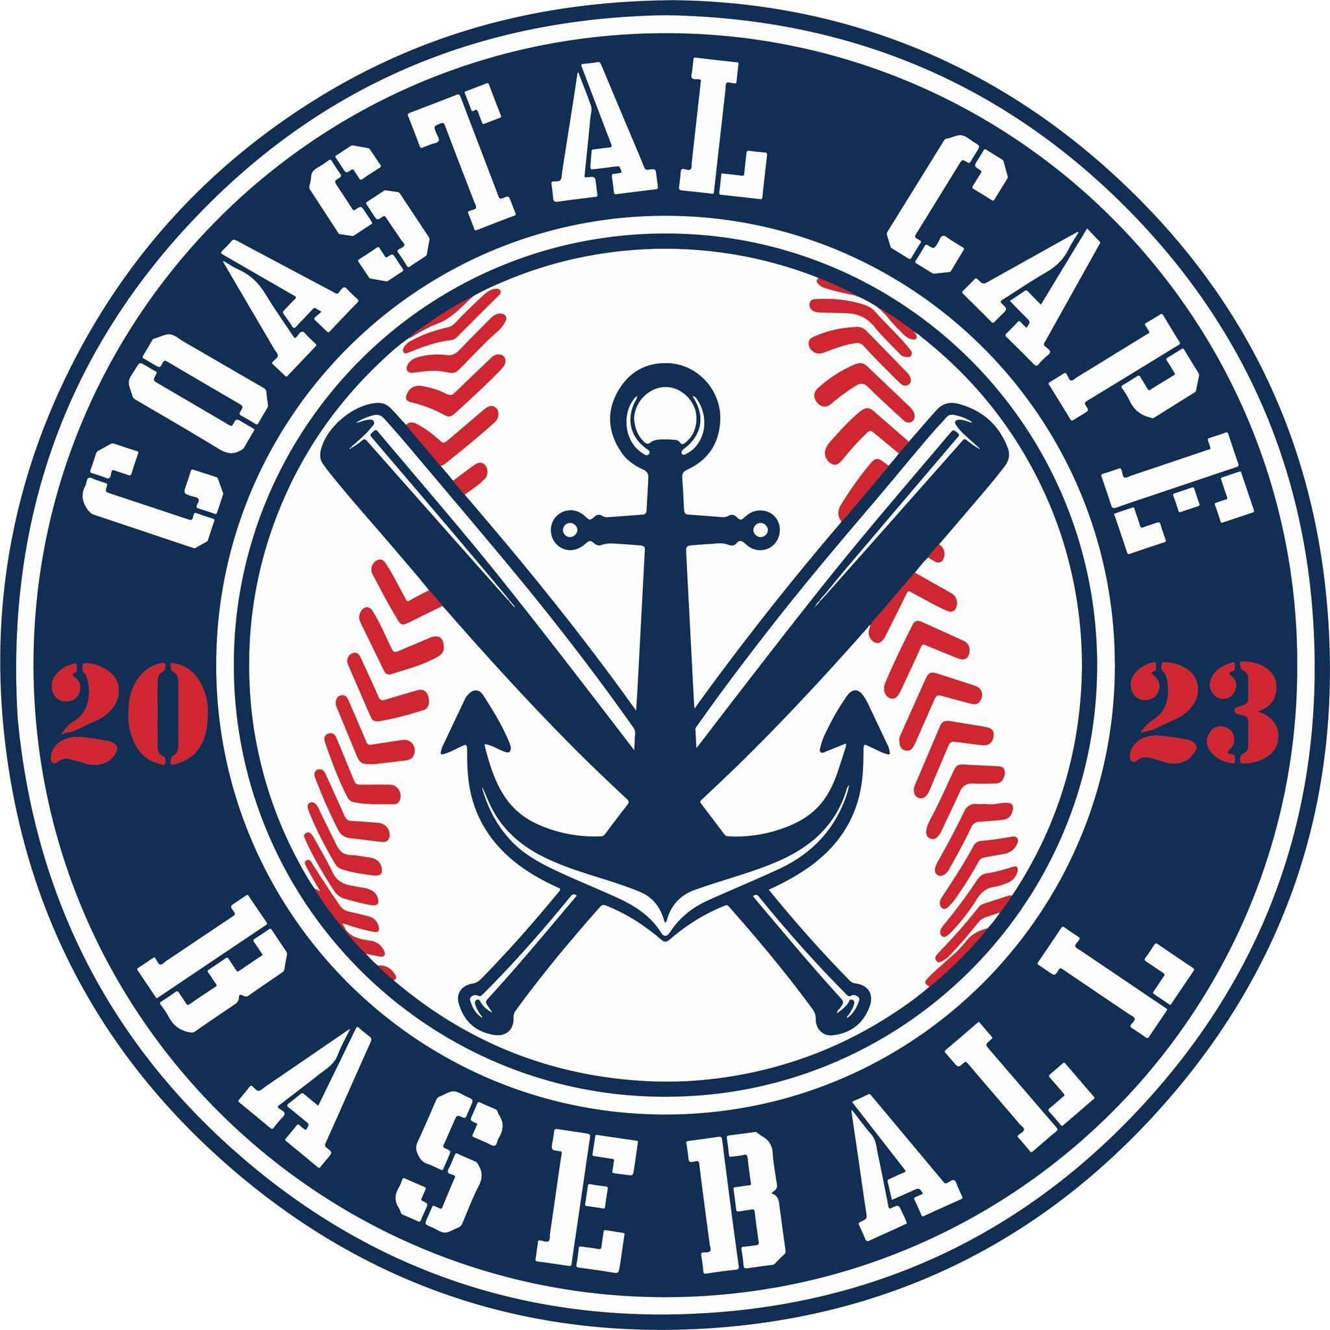

Board Meeting Notes
Date: ________2/9/26______________

Important Dates and Meeting Agenda
(Prior to the Meeting)
Upcoming Important Dates: Majors Draft- Feb 25, Minors Draft- March 2

Next Meeting: Pending confirmation March 9th @ BPD
Agenda:
- Treasurer Report
- Registration
- Evaluations
- Coaches
- Team Sponsors
- Equipment
- Fundraising
- All Stars/Tournaments
- Winter workouts
- Social Media
- Opening Day
- Centeio
- Notetaker - Abby Nye
- Timekeeper
- Discussion Monitor

Topic: Treasurer Report | Presenter: Ken  Time: 6:09-6:18
Notes:  - Insurance $3400/yr covers divisions and board  - Ending balance $42,430.00  - $1,540 TeamSnap annual renewal  - Fairway lawn maintenance for Centeio is free, veg control $556.14 | Actions Items:  - Board approve reimbursement to Ken for TeamSnap yearly renewal  - Abby to send TeamSnap deposits to Ken

Topic: Registration | Presenter: All  Time: 6:18-6:35
Notes:  - 138 total registrations  - Majors 48  - Minors 48  - Rookies 43? | Actions Items:  - Proposal –close Majors registration, any returning Majors players are welcome to return to their existing team before draft, anyone else is on waitlist to Allen  - Proposal – leave minors registration open  - If anyone majors age signs up notify Kevin

Topic: Player Evals | Presenter: Allen/Kevin  Time: 6:35-6:43
Notes:  - Great feedback from players and parents  - Post eval process – Allen takes his pool of majors age/interested data to create draft pool  - Majors draft Wednesday, Feb 25  - Minors draft Monday, March 2 | Actions Items:  - Rosters and sponsors to Kevin immediately after minors draft

Topic: Coaches | Presenter: All  Time: 6:43-6:47
Notes:  - Majors- 4 confirmed  - Minors – looking for 1 head coach  - Rookies- | Actions Items:

Topic: Team Sponsors | Presenter: Bianca  Time: 6:47-6:54
Notes:  - 4 committed and not paid  - 12 committed team sponsors  - Continue to use Cape Tech for banners | Actions Items:

Topic: Equipment | Presenter: All  Time: 6:54-7:15
Notes:  - Used donated gift card from Dicks to purchase catchers gear, every team in minors has a set  - 10 cases for minors/majors due in end of Feb | Actions Items:  - Need to order softies for rookies  - Need batting cage net at Centeio, Al will check net at Eddy to see if we can use  - Jeff will check Magnum for batting tees  - Need 3 rakes  - Kevin checking with Mike H. re: nets  - Centeio needs home plate  - Jeff will check bases at Centeio

Topic: Fundraising | Presenter: Bianca / All  Time: 7:15- 7:47
Notes:  - Prizes for top sellers (player) at each division; $500 at Butlers Sports  - Last year’s calendar raffle contacts have been emailed  - Raffle tickets $10each, asking each player to sell 20 tickets  - Top selling team- Ice cream at JTs Seafood, The Alley in Orleans, Twisted Pizza | Actions Items:  - Raffle tickets to be distributed to coaches at draft, calendar can come later  - Abby order raffle tickets from Thompson’s; add website and venmo QR  - Bianca will make info and tracker sheet

Topic: All Stars /Tournaments | Presenter: Craig  Time: 7:47-7:49
Notes:  - Sandwich  - 4 teams @ $800 | Actions Items:  - Craig to register 4 teams when registration opens for Sandwich

Topic: Winter Workouts | Presenter: Craig  Time: 7:49-7:51
Notes:  - Everythings going great | Actions Items:

Topic: Opening Day | Presenter:  Time:
Notes: | Actions Items:  - Table for next meeting

Topic: Social Media | Presenter:  Time:
Notes: | Actions Items:  - Table for next meeting

Topic: Centeio | Presenter: Kevin  Time: 7:52-
Notes:  - Field is town property not school  - Goal is to give the field back to the town and rent the field from the town | Actions Items:  - Continue this year maintaining field

