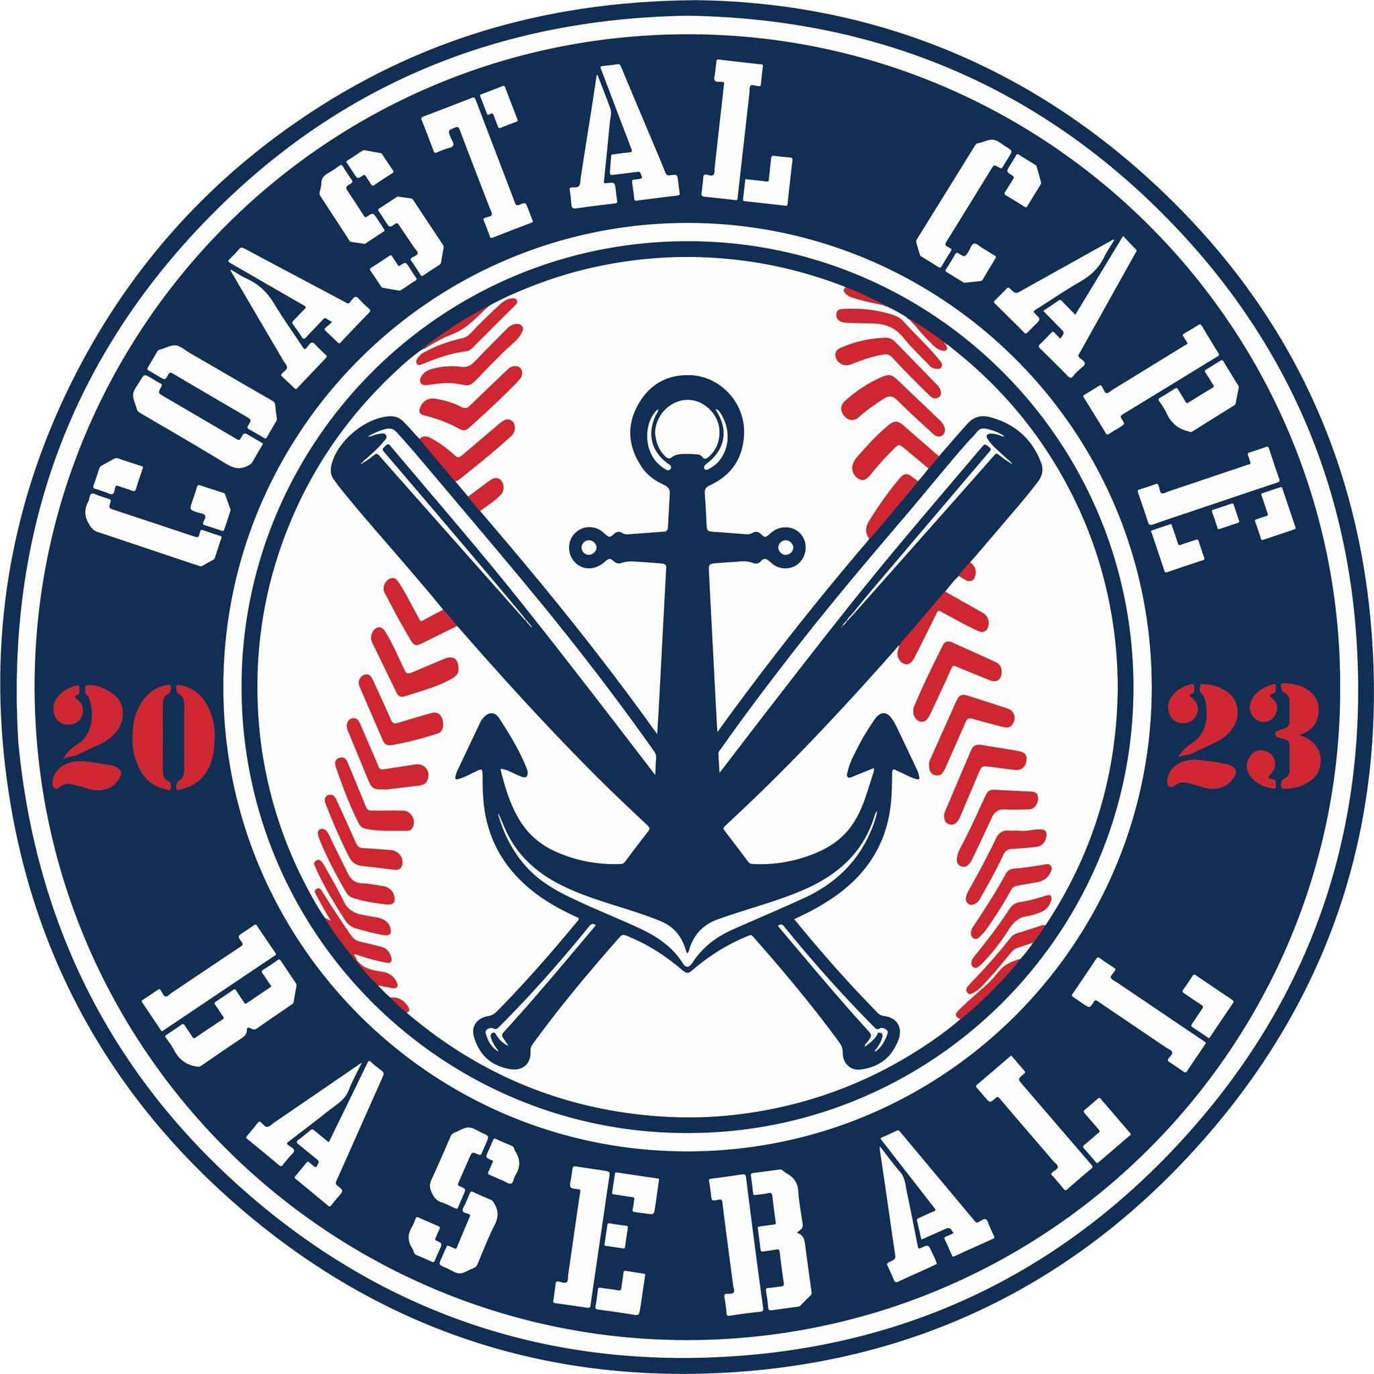

Board Meeting Notes
Date: ________9/24/25______________

Important Dates and Meeting Agenda
(Prior to the Meeting)
Upcoming Important Dates:

Next Meeting: Pending confirmation- October 22nd , 6:00pm @ BPD

Agenda:
- Winter Clinics
- Uniforms/Sponsorships
- Batting Cage
- Coaches
- Scholarships
- Centeio
- Big Ideas/ 2026 Roles

- Notetaker - Abby Nye
- Timekeeper
- Discussion Monitor

Topic: Winter Clinics | Presenter:  Time: 6:05-6:16, 6:49-6:59
Notes:  - Only option to hold clinics at Willys Gym  - Pitcher & Catcher clinics?  - December – February | Actions Items:  - Need to get more people involved to run them  - Jeff, Al & Craig to put note out to coaches to see who can help  - Registration open in October  - Craig to find out what days are open at Willys

Topic: Uniforms/Sponsorships | Presenter:  Time: 6:16-6:30, 7:26-7:28
Notes:  - Evals 2/7 & 2/8  - Draft 2/24 majors & 2/26 minors  - Returning team sponsors $1000  - New team sponsors $1500  - Get sponsor commitments by 12/31/25  - Check only, no more teamsnap payments | Actions Items:  - Uniforms should be ordered March 1st  - Motion to approve team sponsorship rates, approved by board  - Jr Babe ruth will help with raffle tickets

Topic: Batting Cage | Presenter:  Time: 6:30-6:43
Notes:  - Cage to be put up at Gage’s  - Eddy cage needs to come down | Actions Items:  - Al to talk to Mike to make sure it’s ok to put at field  - Craig to take a look at the cage and board approves to pay $500.00 to the Coles

Topic: Coaches | Presenter:  Time: 6:43-6:49
Notes:  - 1 coaching position open at the majors level; depends on registrations and draft  - Coaching at minors depends on draft | Actions Items:  - Send Kevin rookie coaches Name and numbers

Topic: Scholarships | Presenter:  Time: 6:59-7:05
Notes: | Actions Items:  - If people request scholarships, direct to Kevin, they need to volunteer or provide extra fundraising efforts

Topic: Centeio | Presenter:  Time: 7:05- 7:06
Notes: | Actions Items:  - Next meeting; update from Jeff

Topic: Big Ideas/ 2026 Roles | Presenter:  Time: 7:06-7:26
Notes:  - Secretary – Abby Nye  - Minors Director – Jeff Marino?  - All Star Coordinator/ Player & Coach Development – Craig Evans  - Majors Director – Allen Ryone  - Treasurer – Ken Taber  - President – Rich Kochanowicz  - Vice President – Kevin Heinz  - Fundraising/Sponsorship –  - Social Media – Kelly Bicknell  - Jr. Babe Ruth Director – Kevin Heinz  - Rookies Director – | Actions Items:

Topic: | Presenter:  Time:
Notes: | Actions Items:

Topic: | Presenter:  Time:
Notes: | Actions Items:

