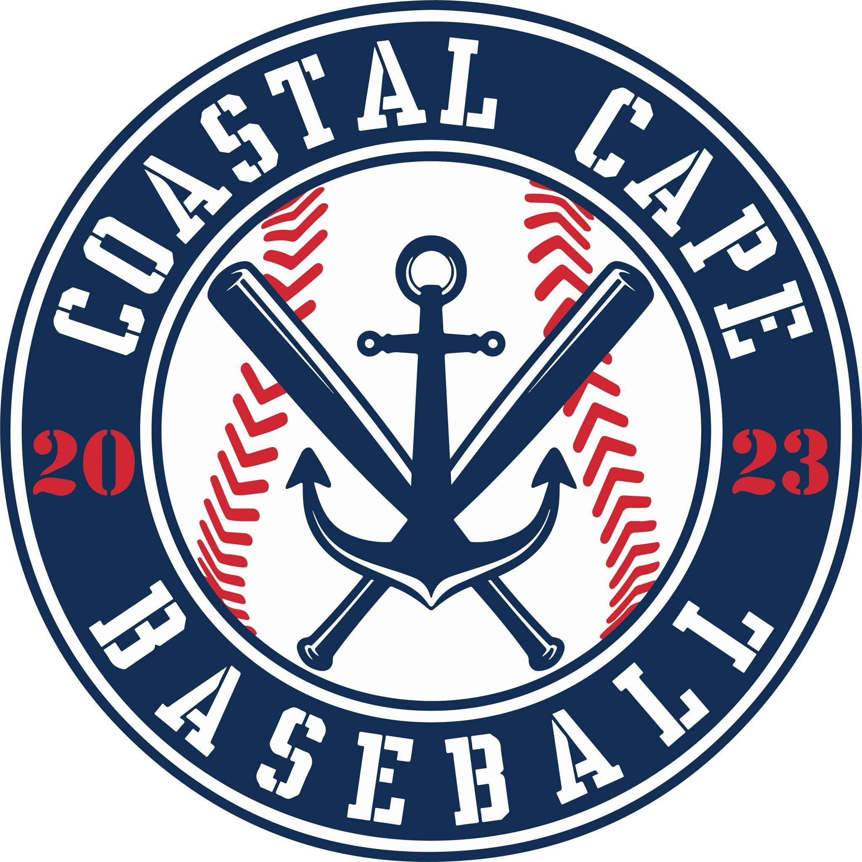

Board Meeting Notes
Date: ________4/16/25______________

Important Dates and Meeting Agenda
(Prior to the Meeting)
Upcoming Important Dates:

Next Meeting:

Agenda:
- Uniforms
- Financials
- Sponsorships
- Raffle
- Opening Day
- All Stars
- Board Positions

- Notetaker - Abby Nye
- Timekeeper
- Discussion Monitor

Topic: Uniforms | Presenter: Board  Time: 6:14-6:36
Notes:  - Patches needed to be ordered direct from Cal Ripken and attached to the uniform | Actions Items:  - Need a budget per player next year

Topic: Financials | Presenter: Ken/ board  Time: 6:36-6:42
Notes:  - Financials accepted by board | Actions Items:  - Need to validate Brewster field usage before paying invoice at end of season

Topic: Sponsorships | Presenter: Sue/Abby  Time: 6:42-6:52
Notes:  - Looking for 2 more all star sponsors | Actions Items:  - Abby send sponsor list by field for banners  - Board men will hang banners, Saturday at 9:00

Topic: Raffle | Presenter: Abby  Time: 6:52-6:53
Notes: | Actions Items:  - All teams have received ticket packages

Topic: Opening Day | Presenter: Board  Time: 6:53-7:10
Notes:  - Seniors from Nauset & Monomoy  - Rain date Sunday 5/4 9:00 AM  - Majors games at 10:00AM & 1:00PM  - Minors games | Actions Items:  - Ken will MC opening day  - Send Ken teams & coach/rosters  - John Castleberry first pitch?  - Need home plates

Topic: All Stars | Presenter: Board  Time: 7:10 – 7:48
Notes: | Actions Items:  - All registrations will be done via check, nothing will go through teamsnap  - Motion Accepted: All spending at Butlers will be shut off as of 4/16/2025  - Motion Accepted: Each all star team will be allotted $1,000 out of coastal cape funds. The remainder will need to come from families or outside sponsors.

Topic: Board Positions | Presenter: Kevin  Time: 7:48-7:50
Notes: | Actions Items:  - Starting thinking about your spot next year

