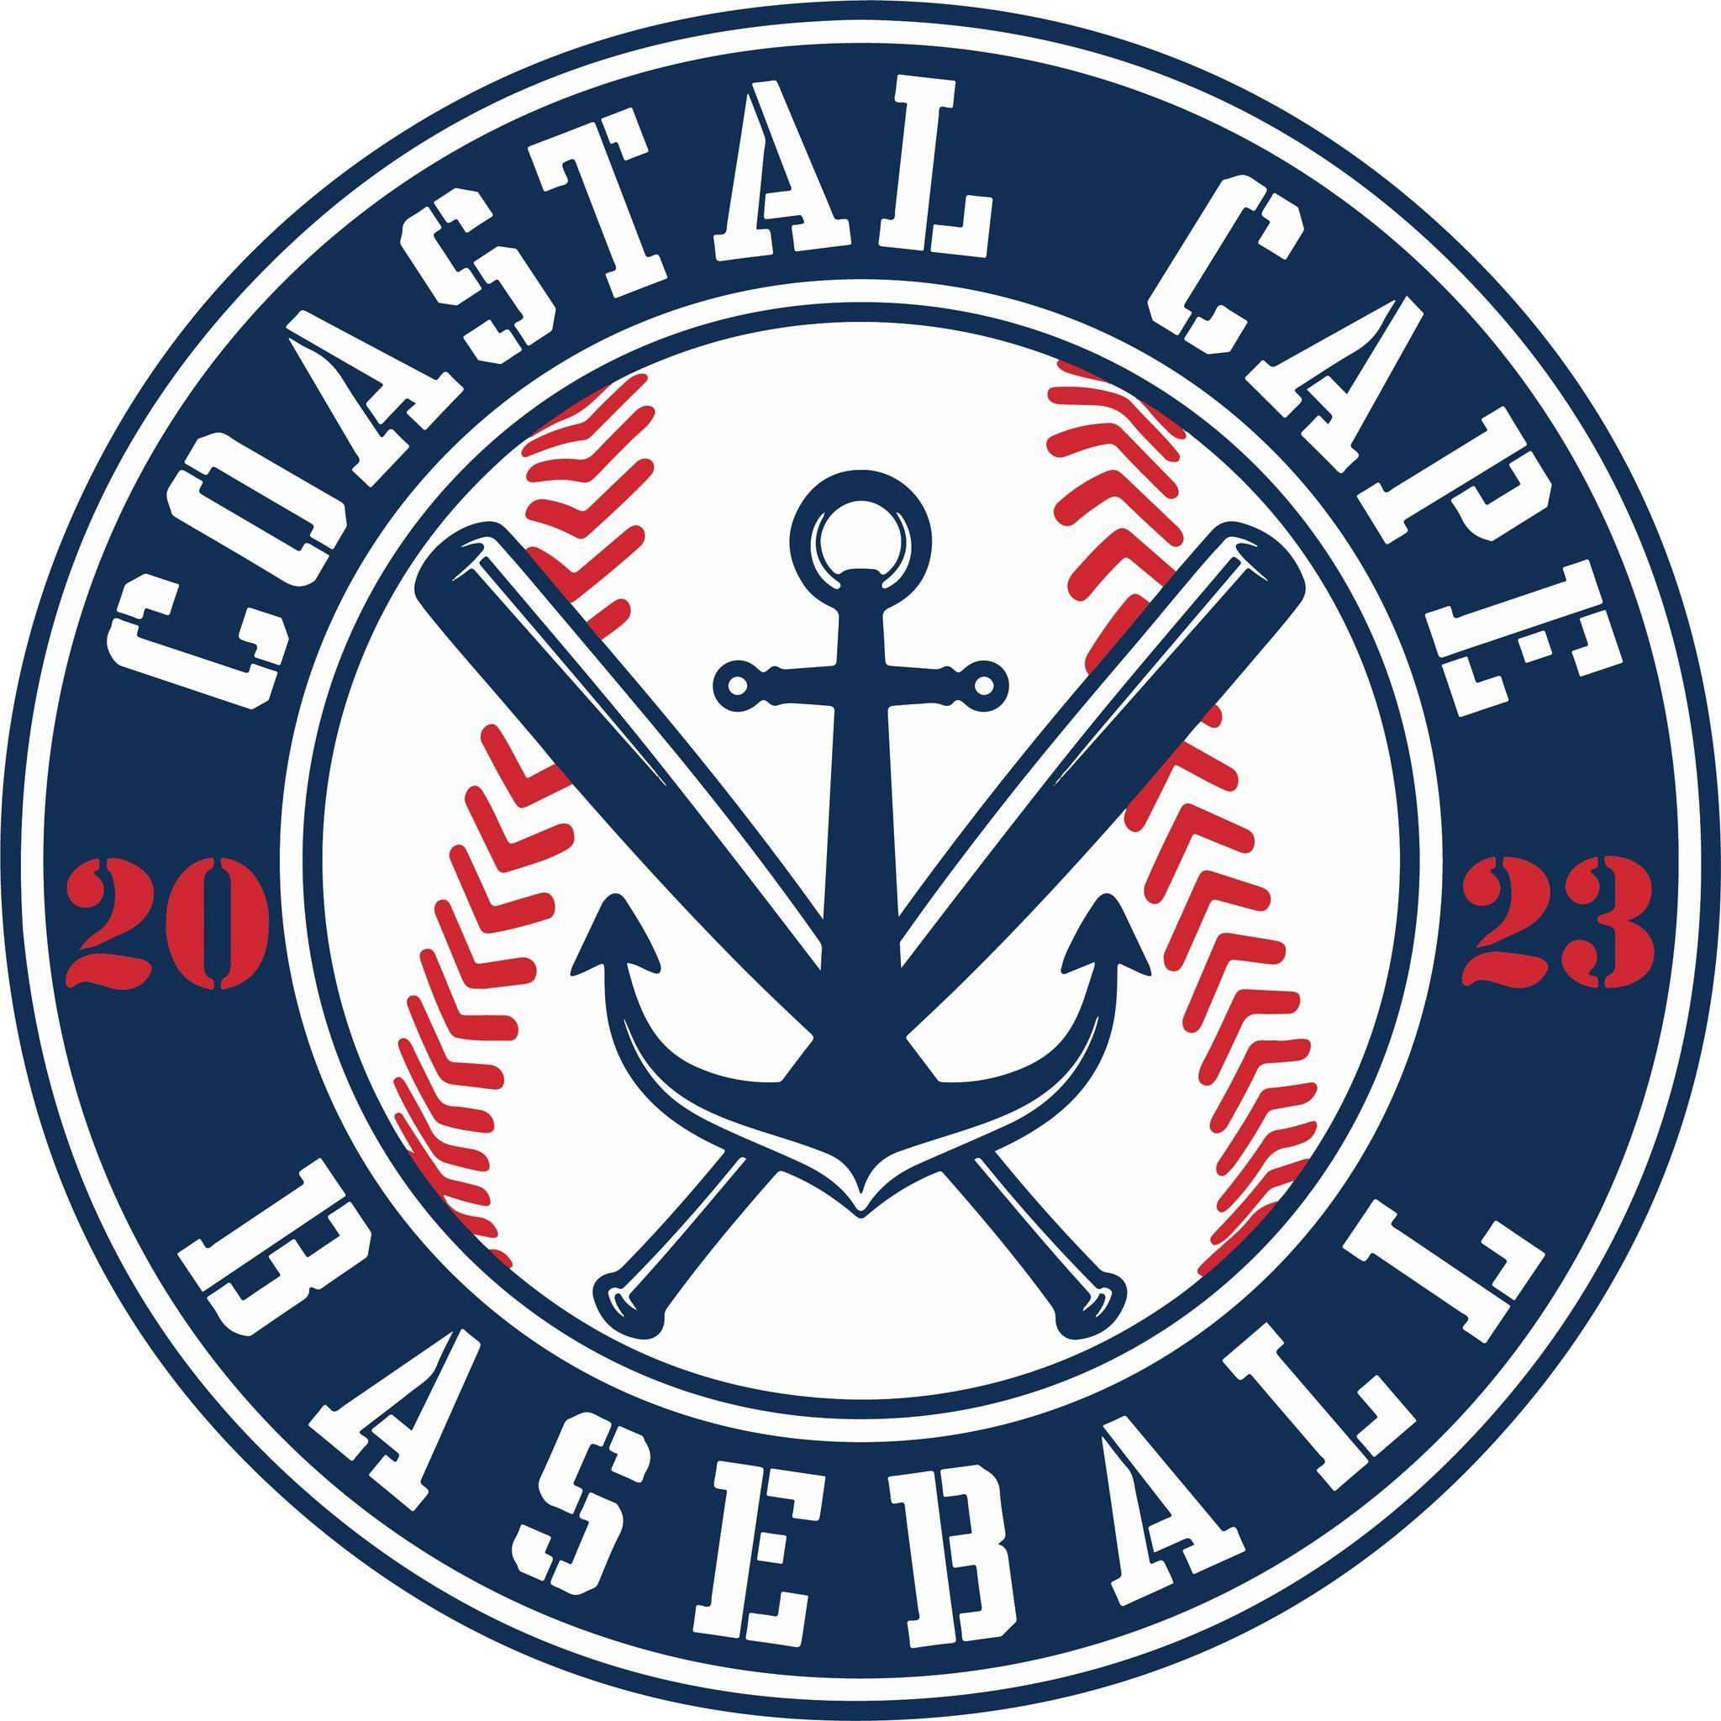

Board Meeting Notes
Date: ________12/15/25______________

Important Dates and Meeting Agenda
(Prior to the Meeting)
Upcoming Important Dates:

Next Meeting: Pending confirmation- January 12th @ Brewster PD
Agenda:
- Financials
- Registration
- Sponsorship/ Fundraising
- Opening Day
- Coaches
- Social media/ red sox/ fun stuff
- Winter workout
- Notetaker - Abby Nye
- Timekeeper
- Discussion Monitor

ABBY WON BINGO!!!!!!!!!

Topic: Financials | Presenter: Ken  Time: 6:10-6:20
Notes:  - Taxes are being filed  - Insurance binders 1/31/26  - Boxwoods, Monomoy Home checks received | Actions Items:

Topic: Registration | Presenter: Abby/Kevin  Time: 6:20-6:22
Notes:  - 37% of returning players have signed up  - 1 definite not returning, 1 maybe not returning | Actions Items:

Topic: Sponsorships/ Fundraising | Presenter: Bianca  Time: 6:22-7:40
Notes:  - 9 committed, 4 paid (Boxwoods, Mazzeo, Monomoy Home, Cape Dreams)  - Dicks Sporting Goods sponsorship  - Red Sox have been contacted for donation, raffle idea,  - PTOs have been contacted  - Using a team parent at each division to help the teams organize raffles, snack shack etc  - Utilizing Dairy Queen or other ice cream shops for kick back  - Long term goals to help with scoreboards, fields etc  - Community Engagement – polar plunge, beach clean ups,  - Meet the coach night at local restaurant | Actions Items:  - Find remaining 4 teams sponsors

Topic: Opening Day | Presenter:  Time:
Notes:  - April 11th | Actions Items:  - Bring snow shovels

Topic: Coaches | Presenter: All  Time: 7:47-7:56
Notes:  - Minors – 4 confirmed  - Rookies – 2 confirmed  - Majors – Tom Deegan, Rich Dulgarian, Craig, Allan Peterson  - 29 with valid background checks | Actions Items:  - 5 Board members need to do background checks

Topic: Social Media / Red Sox / Fun things | Presenter: Kelly  Time: 7:56-8:31
Notes:  - COASTAL CAPE DAY @ FENWAY JUNE 30th  - Fundraising aspect on ticket sales  - 15 kids have the chance to come on the field if we sell 150 tickets  - Purchase game day chains for the MVP  - Purchase helmet stickers in lieu of game ball  - Stats sent into Kelly for socials  - Little Fenway game at Barnstable for Rookies | Actions Items:  - Motion to lock in 50 tickets & the date, accepted but 1 Yankee fan voted against this magical Coastal Cape Fenway Day  - Convince Allen to allow walk up songs in majors

Topic: Winter workouts | Presenter: Craig/Jeff  Time: 8:31
Notes:  - Great first week, big group for majors | Actions Items:

Topic: | Presenter:  Time:
Notes: | Actions Items:

Topic: | Presenter:  Time:
Notes: | Actions Items:

Topic: | Presenter:  Time:
Notes: | Actions Items:

Topic: | Presenter:  Time:
Notes: | Actions Items:

