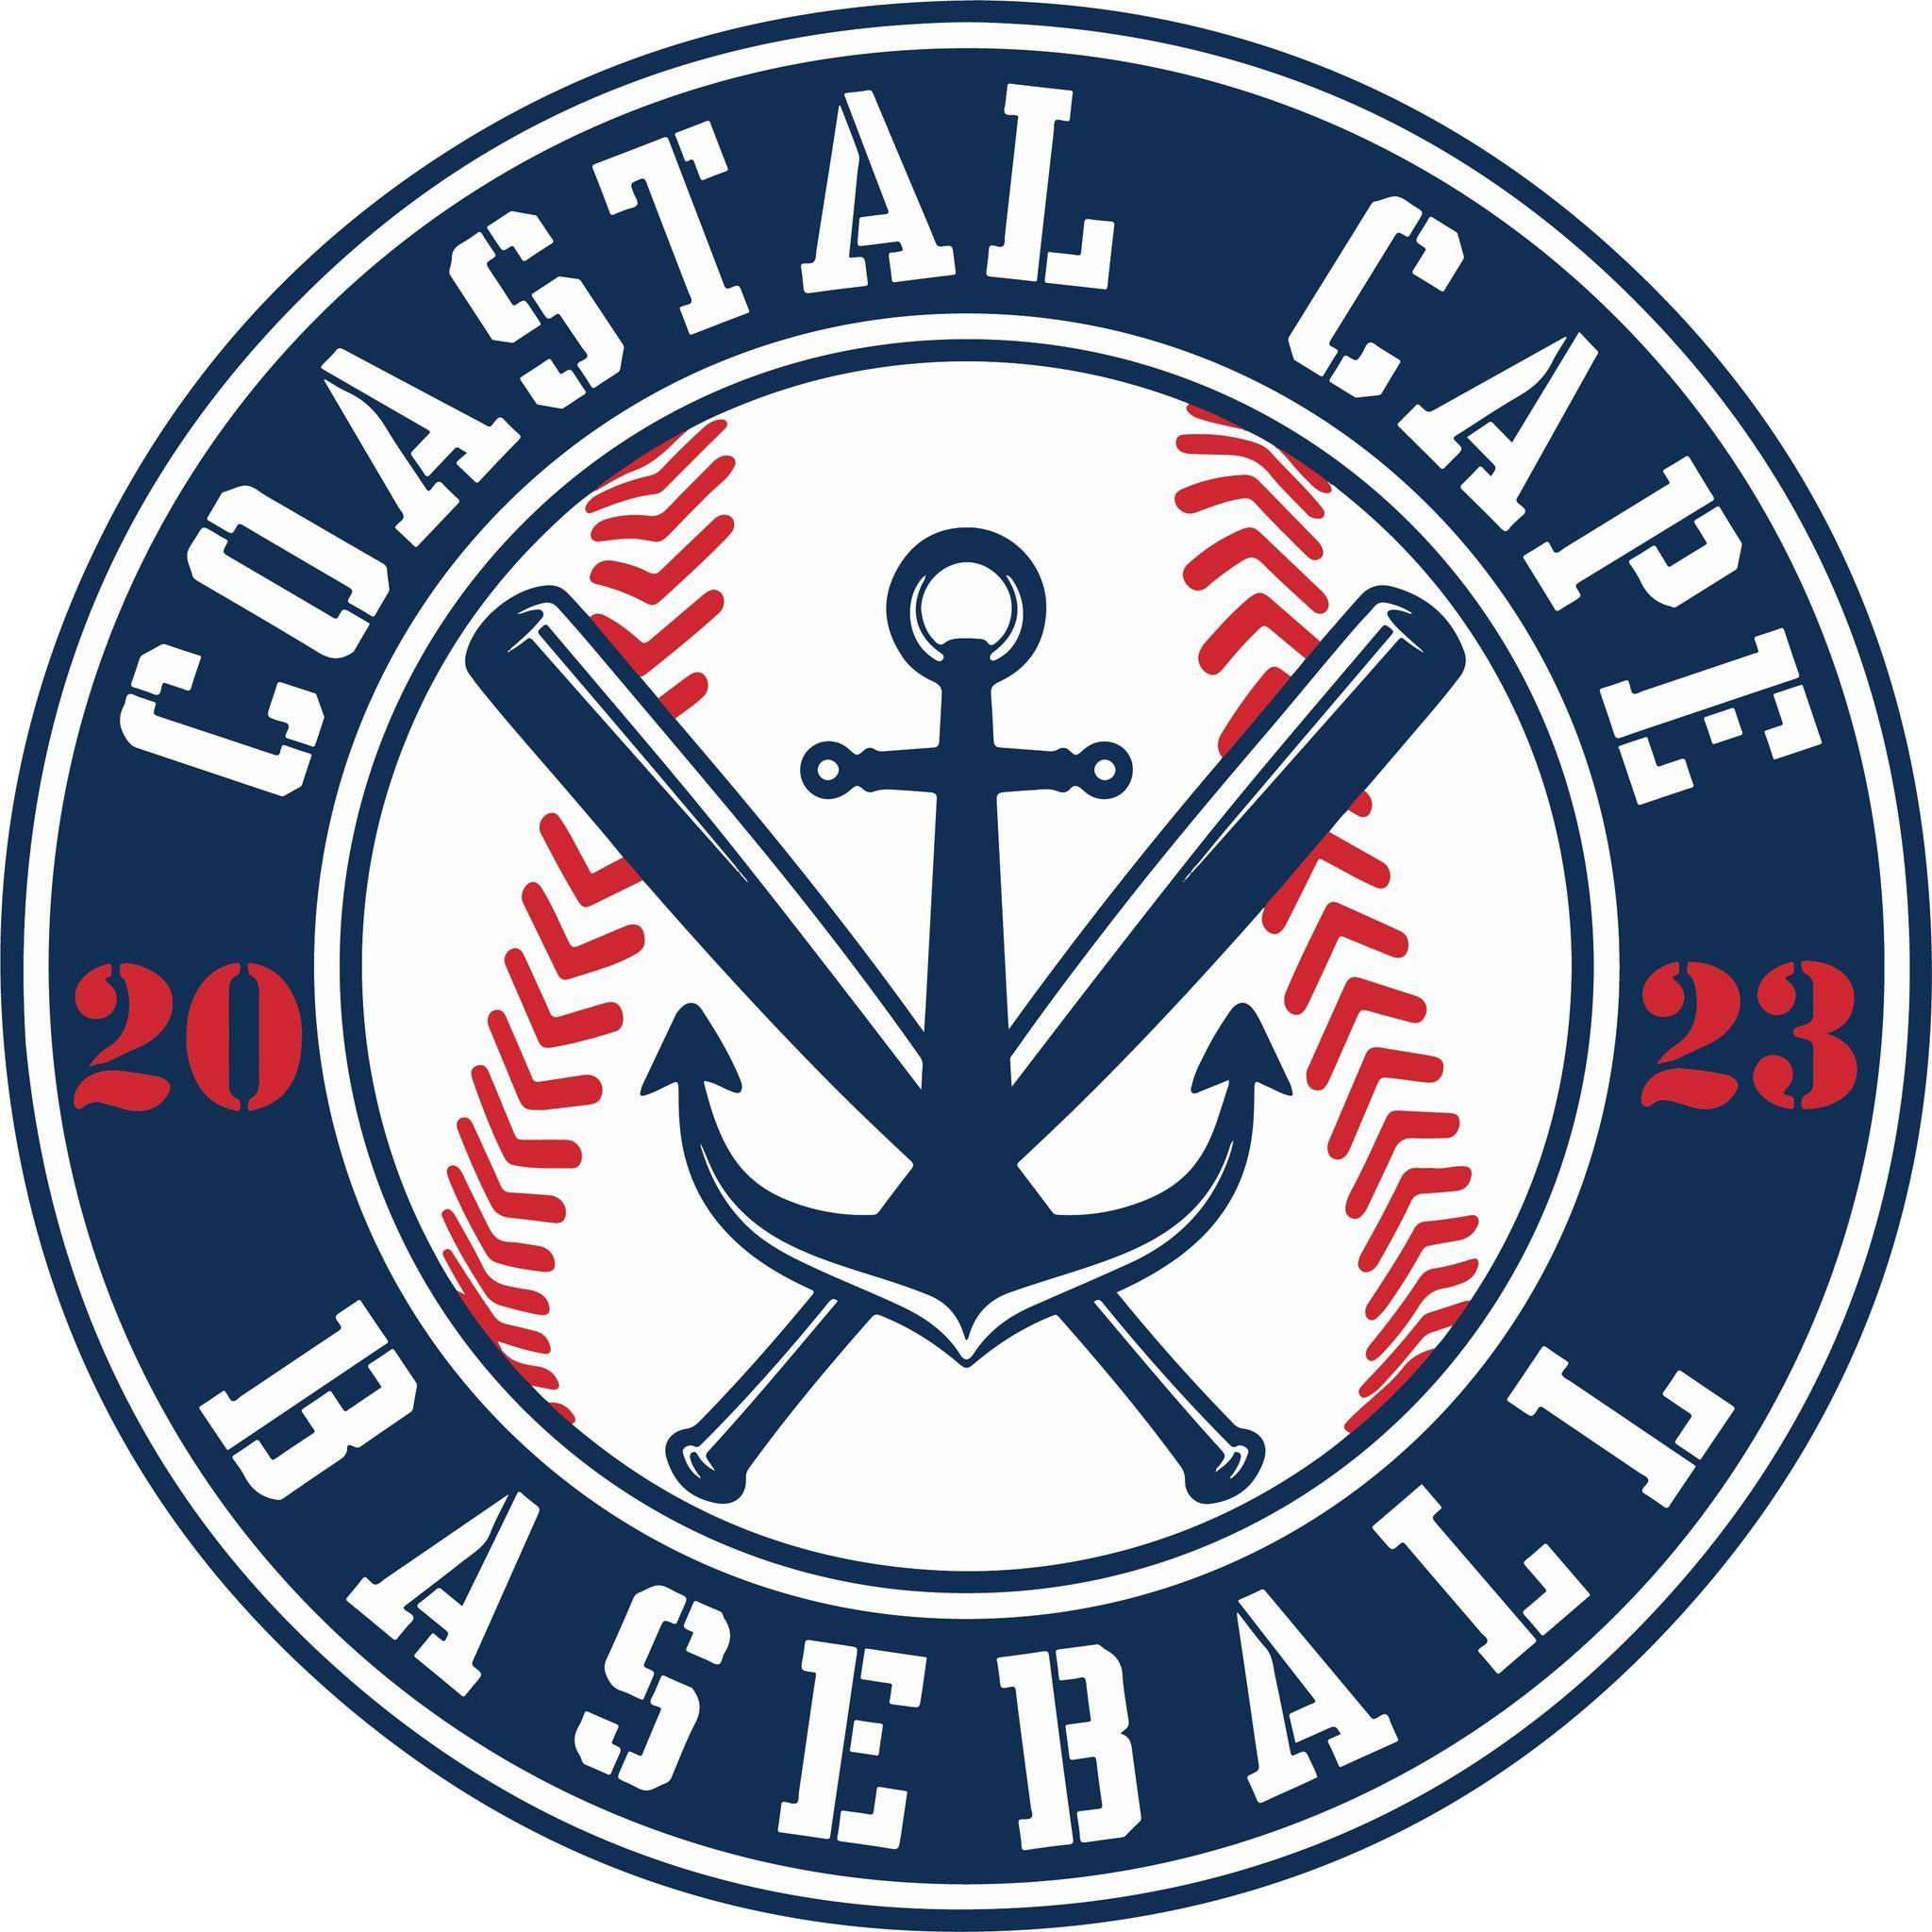

Board Meeting Notes
Date: ________11/19/25______________

Important Dates and Meeting Agenda
(Prior to the Meeting)
Upcoming Important Dates:

Next Meeting: Pending confirmation- December 15th @ Brewster PD

Agenda:
- Financials
- Social Media
- Winter Clinics
- Open Board Positions
- Fields
- Centeio
- Equipment
- Coaches

- Notetaker - Abby Nye
- Timekeeper
- Discussion Monitor

6
Topic: Financials | Presenter: Ken  Time: 6:08-
Notes:  - Outstanding payments – batting cage, lights | Actions Items:  - Once approved by board will forward to accountant to be paid for the 2025 season

Topic: Social Media | Presenter: Kelly  Time: 6:28-6:37
Notes: | Actions Items:  - Push for spring registration & winter clinics  - Send email looking for coaches to help run winter clinics

Topic: Winter Clinics | Presenter: Kevin, Jeff, Craig  Time: 6:31-6:37, 6:54-7:01
Notes:  - Willy’s gym has been paid | Actions Items:  - Send email looking for coaches to help run  - Offer coaching to Jr. Umpires  - Refund Michael Cormier  - Bring L screens, need bases, nets, med kit, softees  - Craig to order pancake gloves

Topic: Directors/ Open Positions | Presenter: All  Time: 6:37-6:54
Notes: | Actions Items:  - Think of ways how to grow rookie program  - Motion to make Corbin Mitchell rookie director was voted on and accepted

Topic: Fields | Presenter: All  Time: 7:01-7:17
Notes: | Actions Items:  - FREEMANS= Need mounds built up, home plate at majors field need attention, need lining machines,  - GAGES= Need to have mound repaired by town  - EDDY= Needs fence work (school committee needs to approve), poison ivy at backstop needs to be kill  - CENTEIO – backstop needs repair, batting cage net, 3rd base dugout fence, need new home plate, mound repair, scoreboard, shed broken window, storage container needs to be removed, Jeff to check bases, need L screen, need to remove broken picnic tables

Topic: Centeio-Baldwin Field | Presenter: Jeff  Time: 7:17-7:28
Notes: | Actions Items:  - Jeff to set meeting with Jeff Handler to discuss take over the ownership of the field

Topic: Equipment | Presenter: Kevin  Time: 7:28-7:32
Notes:  - Kevin ordered 4 catchers set from Dicks w/ gift card donation, needs to order 2 more  - Baseballs and softees have been ordered | Actions Items:  - Need to purchase 4 rakes ($100each)  - 1-2 L-screens  - Need 2 more sets of catchers gear, maybe

Topic: Coaches | Presenter: All  Time: 7:32-7:52
Notes:  - MAJORS – all set  - MINORS – depends on kids that move to majors and how many teams are  - ROOKIES – Corbin will work with Jeff  - BABE RUTH – coaching shortage | Actions Items:  - Next meeting we should have a definite idea of coaches  - Need coaches background checked  - Need to find ways to make it fun, have a standard for coaches

Topic: | Presenter:  Time:
Notes: | Actions Items:

Topic: | Presenter:  Time:
Notes: | Actions Items:

Topic: | Presenter:  Time:
Notes: | Actions Items:

