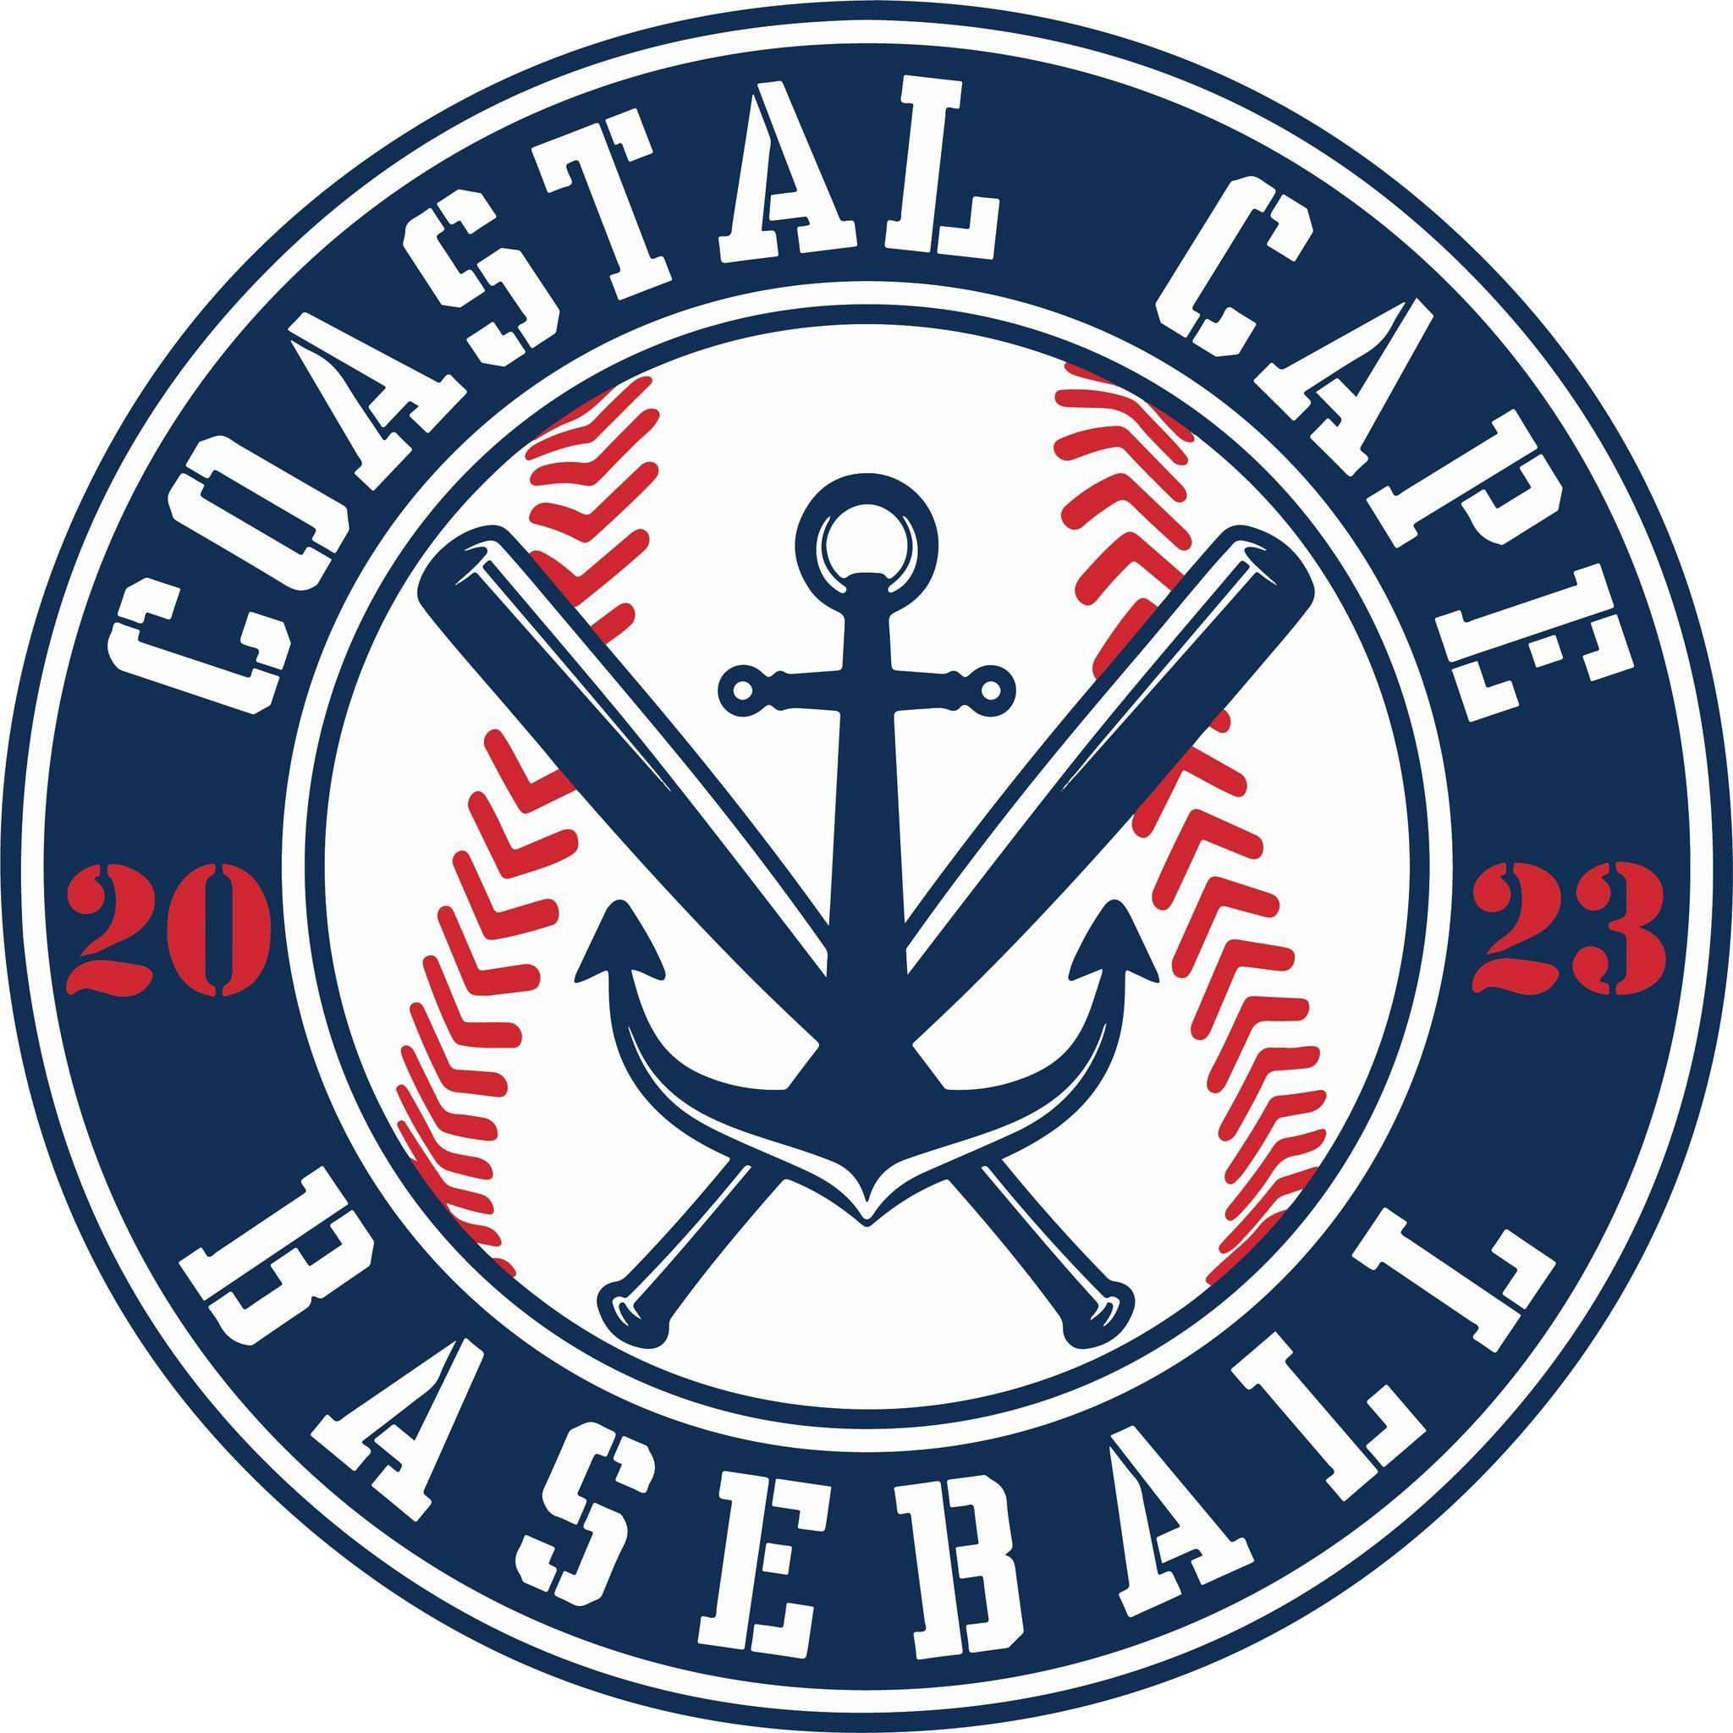

Board Meeting Notes
Date: ________10/23/25______________

Important Dates and Meeting Agenda
(Prior to the Meeting)
Upcoming Important Dates:

Next Meeting: Pending confirmation- November 19, location TBD

Agenda:
- Financials
- Open Positions
- Winter Workouts
- Cole Batting Cage
- Fall Ball
- Jr Babe Ruth Fall Ball
- Equipment
- Fields
- Centeio
- Registration

- Notetaker - Abby Nye
- Timekeeper
- Discussion Monitor

6
Topic: Financials | Presenter: Ken  Time: 6:14-6:30
Notes:  - Financials will be closed out through 9/30/25  - Ken would like checks for sponsorships instead of team snap | Actions Items:

Topic: Open positions on the Board | Presenter: All  Time: 6:30-6:58
Notes:  - Bianca – Fundraising/ Sponsorship  - Director of Rookie  - Kelly – Social Media/Communications  - Jeff taking over Director of Minors  - Director of Rookies position open | Actions Items:  - Board voted on new positions and accepted Bianca and Kelly  - Board voted on new position social media/communication Director  - Board voted on Jeff to take over the role of minors director  - Jeff checking on rookies director

Topic: Winter Workouts | Presenter: Craig  Time: 6:58-7:10
Notes:  - $3600 for 8 weeks on Thursday nights (3 hrs night)  - Rookie/Minors 8-10yr old 5-6:30pm, Majors 10-12yrs 6:30-8pm  - Starting 12/11 start, end before evals  - Cap at 13 players per group  - $160 (8 session) | Actions Items:  - Open registration once Ken pays Willys and dates are secured  - Board voted to approve winter clinics

Topic: Coles Batting Cage | Presenter: Craig  Time: 7:10-7:21
Notes: | Actions Items:  - 11/11 dismantle and install batting cage

Topic: Sponsorships | Presenter: Kevin  Time: 7:22-7:23
Notes:  - 9 confirmed returning team sponsors  - 1 paid (Mazzeo Pool) | Actions Items:

Topic: Fall Ball | Presenter: Jeff/Craig  Time: 7:23-7:27
Notes:  - Been great, very instructional | Actions Items:

Topic: Jr Babe Ruth Fall Ball | Presenter: Al  Time: 7:27-7:34
Notes:  - 2 teams of 30 kids | Actions Items:  - Kelly promote coastal vs coastal 6:00 game on 10/25

Topic: Equipment | Presenter: Kevin  Time: 7:35-7:42
Notes:  - Rookies – 2 set of catchers equipment, 1 case of soft baseballs  - Minors – 3-4 catchers sets  - Winter clinics – 4 dozen soft baseballs  - Majors –  - Each field 4 wheel liners, rakes  - Jr Babe Ruth – 2 wheels for jug machine  - Fielding pitching machine | Actions Items:  - Kevin will get cost together

Topic: Fields | Presenter: Kevin  Time: 7:42-7:45
Notes: | Actions Items:  - Check pitching mounds and bases  - Al to repair shed at Gages

Topic: Centeio | Presenter:  Time: 7:45-7:46
Notes:  - Whittemore winterize irrigation | Actions Items:  - Jeff to talk w/ Jeff Handler

Topic: Registration | Presenter: All  Time: 7:46-
Notes:  - Open spring registration nov 15 – 12/31 – majors & minors $225, rookies $150  - Jan 1 – Feb 1 $245 majors minors  - Turn on processing fees to players | Actions Items:

