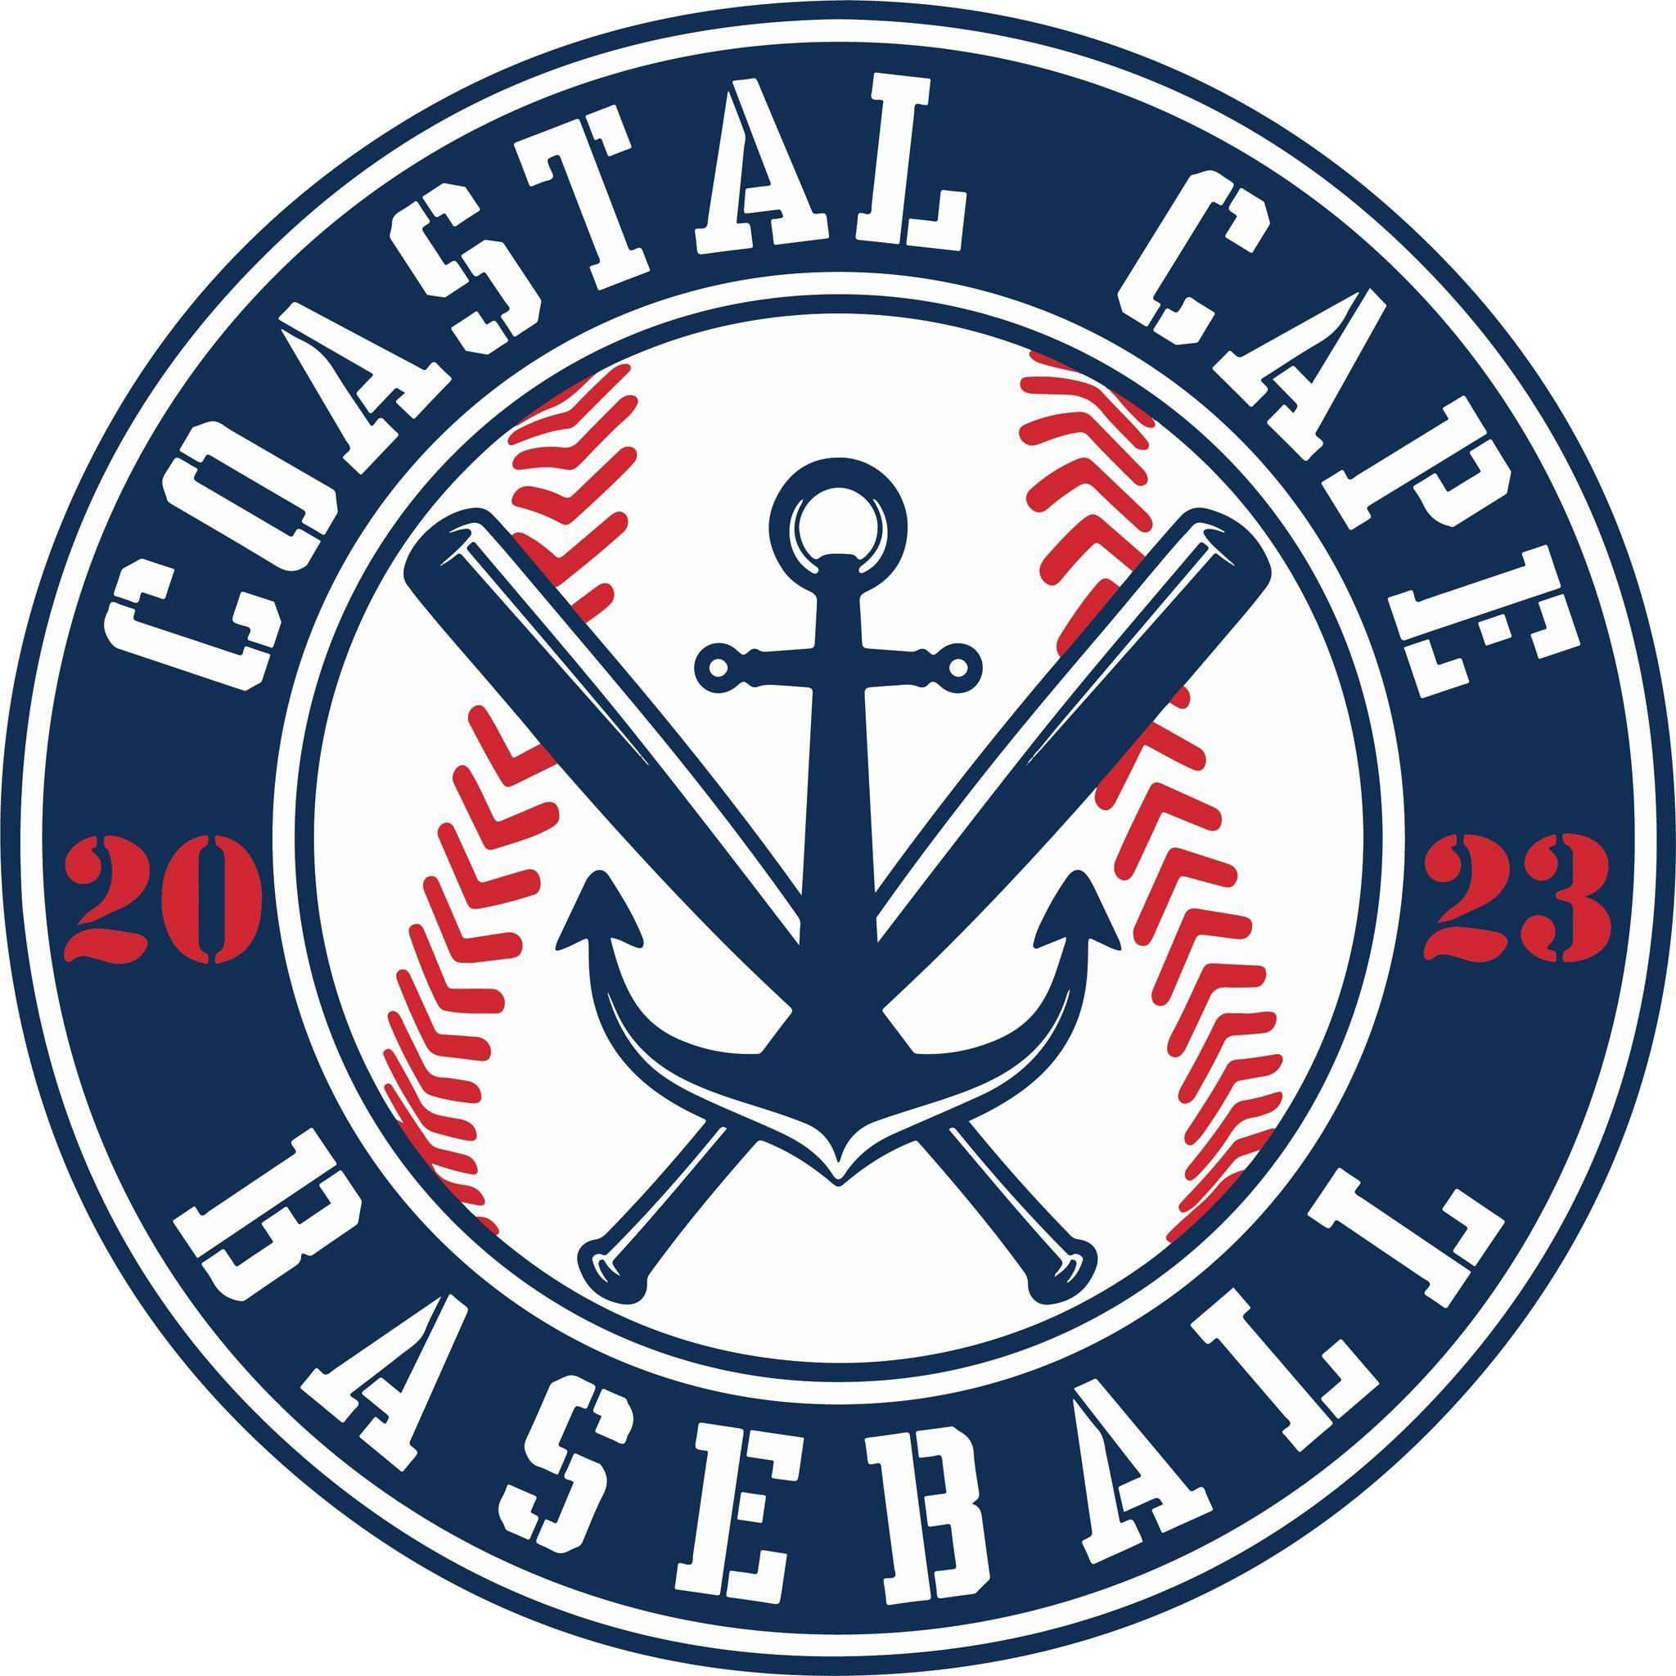

Board Meeting Notes
Date: ________1/22/25______________

Important Dates and Meeting Agenda
(Prior to the Meeting)
Upcoming Important Dates:

Next Meeting: 2/26 , 6PM @ BPD

Agenda:
- Financials
- Winter Clinics
- Evals
- Registration
- Fundraising/Sponsor
- Scoreboards

- Notetaker - Abby Nye
- Timekeeper -
- Discussion Monitor -

Topic: Financials | Presenter: Ken Taber Time: 6:10-6:22
Notes:  - Taxes have been filed for 2023 and 2024  - $1600 fee (800/yr)  - Reviewed P&L to date  - Financials approved by board | Actions Items:  - Ken to send insurance certificate to Kevin for coaches (K&K Insurance)

Topic: Winter Clinics | Presenter: Jeff & Craig  Time: 6:22-
Notes:  - Everything running smoothly | Actions Items:  - none

Topic: Evaluations | Presenter: Board  Time: 6:22
Notes:  - March 8 10-12 minors, 12-2 majors  - March 9 10-12 majors, 12-2 minors | Actions Items:  - Put information on website

Topic: Registration | Presenter: Board  Time:
Notes:  - Low numbers, need to promote, advertise deadline and waitlist | Actions Items:  - Abby to send registration deadline email  - Sue looking into yard signs

Topic: Sponsorship/Fundraising/Raffle | Presenter: Board  Time: 6:45-
Notes:  - 6 committed team sponsors | Actions Items:  - Ben handling raffle  - Everyone is helping out with finding sponsors

Topic: Scoreboards | Presenter: Craig / Board  Time: 6:48-
Notes:  - Looking into scoreboards at Brewster and Harwich  - Lifetime sponsors to donate  - Temporary battery scoreboards for this year | Actions Items:  - Need to look into solar companies/funding

